Name: Pranali Sonawane
Subject: MCSA
Date: 17-12-2025
Lab 13: Group

Types of Group: 1. Security Group
2. Distribution Group

1. Security Group:
- Global Group
- Universal Group
- Domain Local Scope

Server 2:
1.Global Group :
Tools Active Directory Users and Computers users Create 3 Group and Each Group has 3 Users

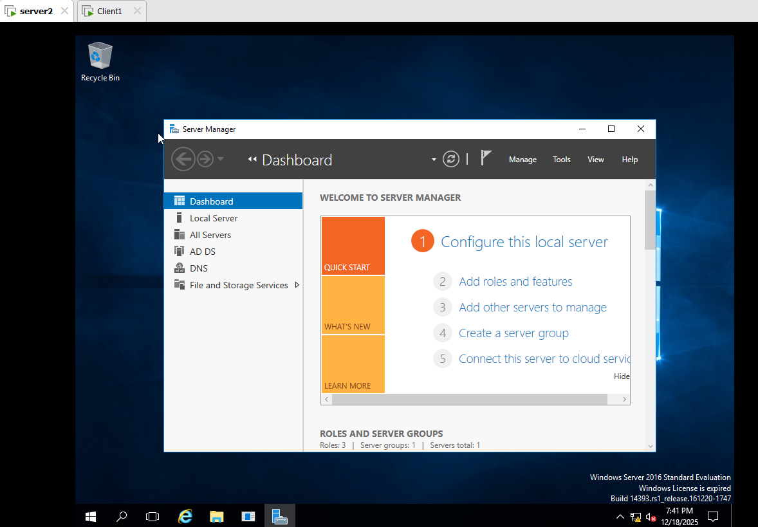

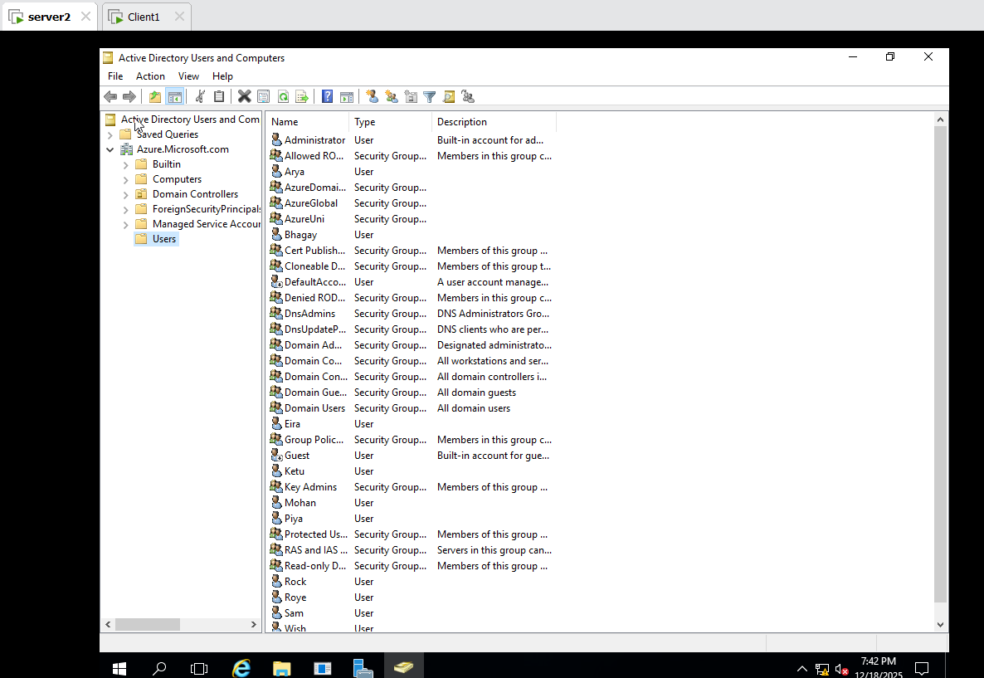

First Group AzureGlobal select Group Scope has Global ok
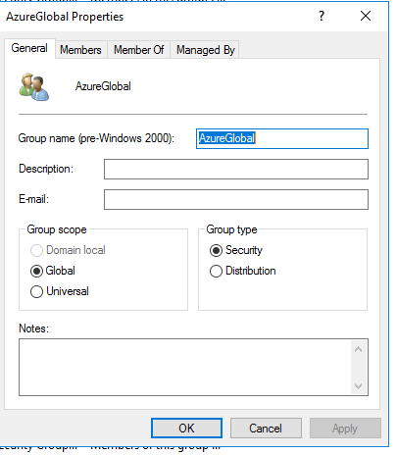
AzureGlobal Add Member ok

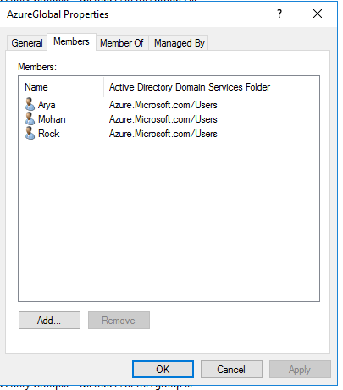
2.Universal Group:
Group AzureUniversal select Uniserval Scope has Global ok
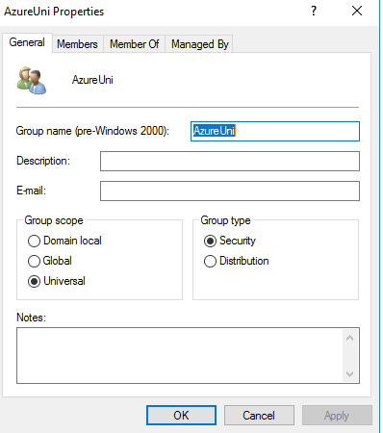
AzureUniversal Add Member ok

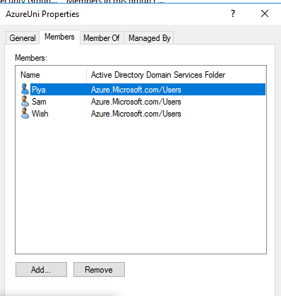
3.Domain Local Scope :
Group AzureDomainLocalselect Domain Local Scope has Global ok
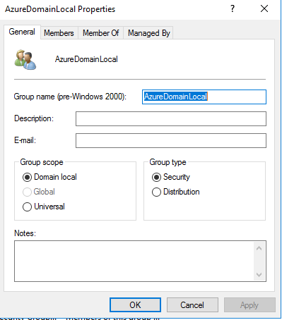
AzureDomainLocal Add Member ok

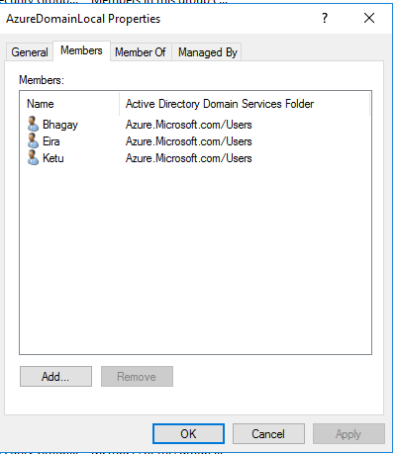
Server 1:
1.Global Group :
Tools Active Directory Users and Computers users Create 3 Group and Each Group has 3 Users
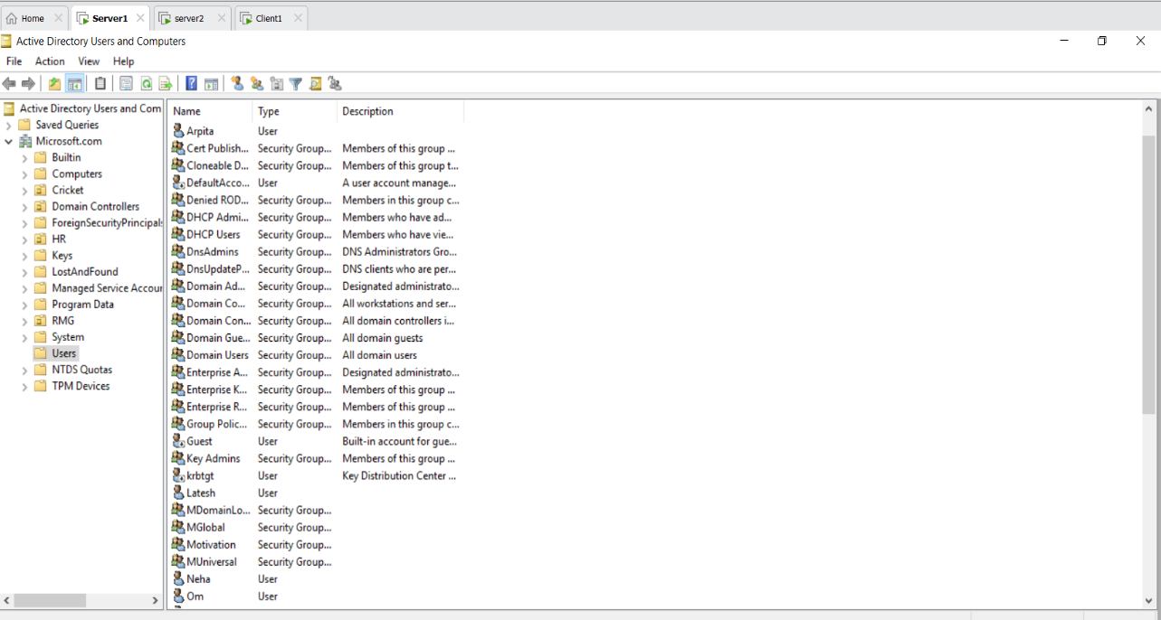
First Group MGlobal select Group Scope has Global ok

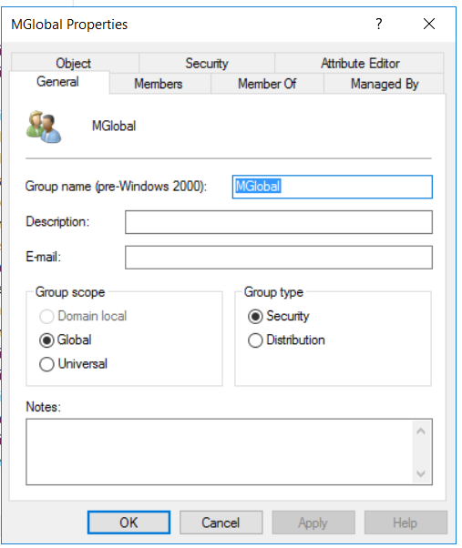
MGlobal Add Member ok

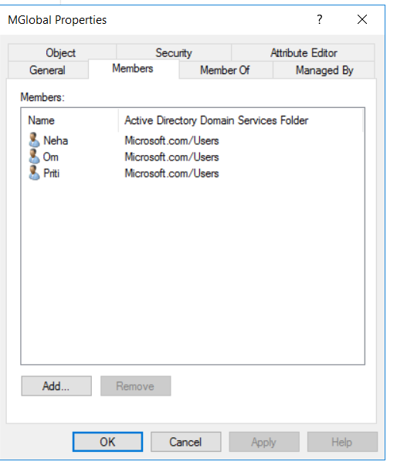
Group MUniversal select Group scope has Universal ok

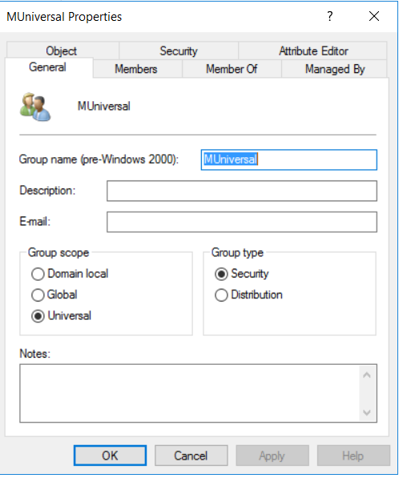
MUniversal Add Member ok
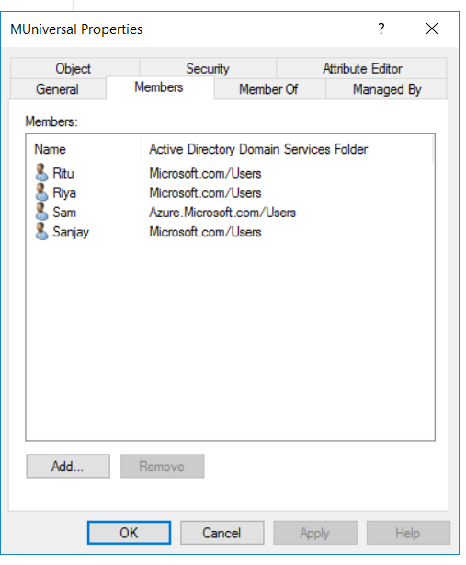
Group MDomainLocal select Group scope has Domain Local ok

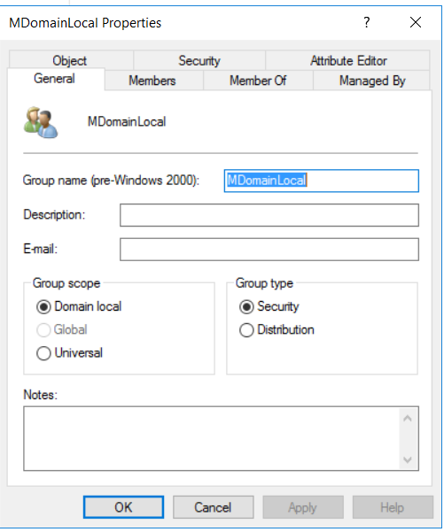
MDomainLocal Add Member ok
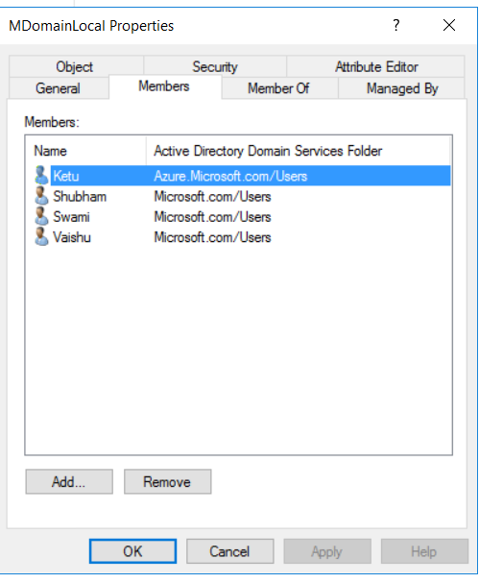

Server1:
MDomainLocalAdd UserAzure.Microsoft.com

